**1. Prerequisites**

* **Security group** with only 22 ports allowed for Linux EC2

* **EC2 instance**

* **VPC endpoint**

**2. Create a VPC endpoint**

This VPC endpoint has to be created in the **VPC where the EC2 instance resides.**

Let's see how to create the VPC endpoint.

Before proceeding to create the VPC endpoint, note down the VPC in which the EC2 instance is created.

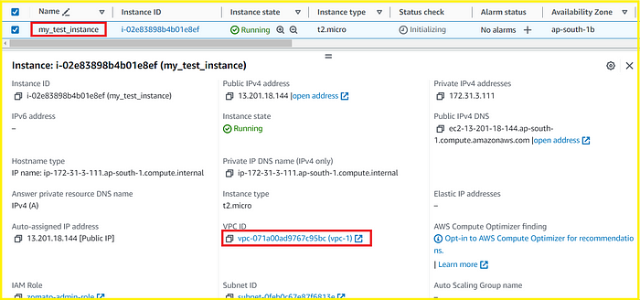

Navigate to the **AWS VPC console >> Endpoints >> Create endpoint**

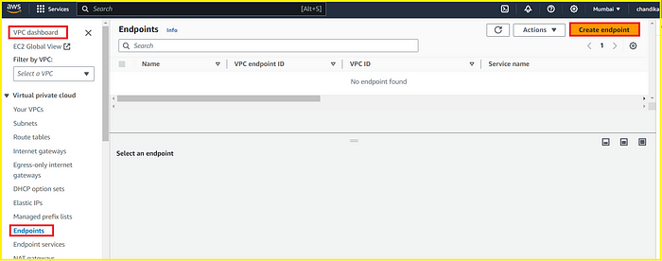

Enter the **Name**of the VPC endpoint: my-test-endpoint

**Service Category:**EC2 Instance Connect Endpoint

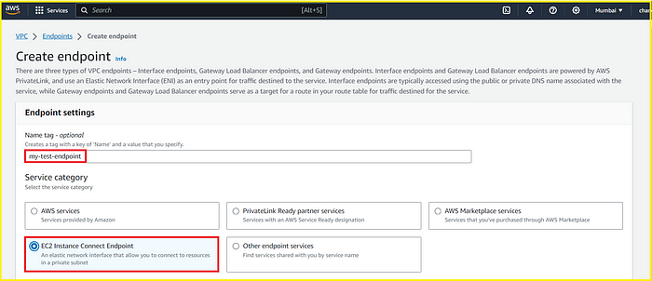

Choose the **VPC ID** of the EC2 instance

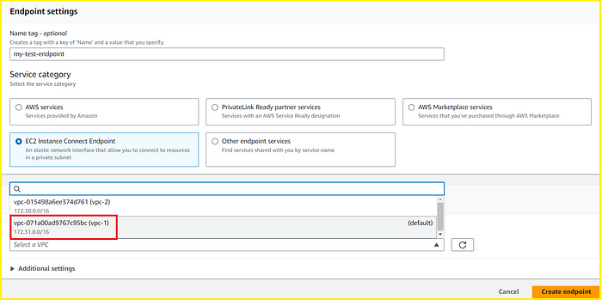

Specify the **security groups** to associate with the endpoint network interface. The security group rules control the traffic to the endpoint network interface from resources in your VPC.

To uphold security best practices, I have created a security group “endpoint-sg” with access to port 22 from my IP.

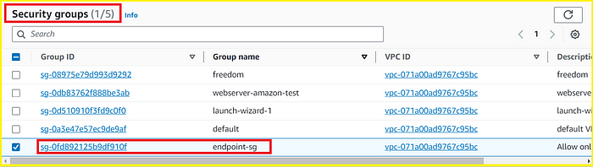

Select the **subnet**in which to create the endpoint.

**Note**: You might create the endpoint in any AZ within the region*

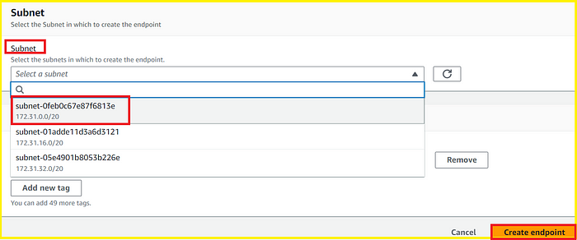

The initial status would be **pending**. Please wait until it becomes A**vailable.**

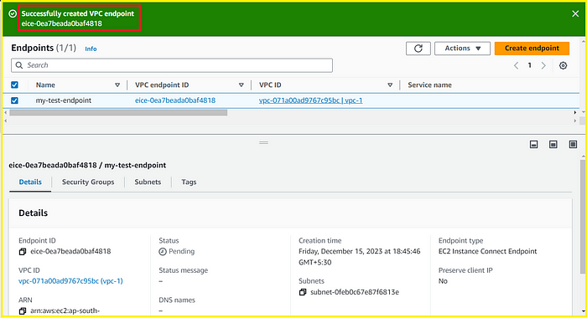

Please wait till the status becomes **Available.**

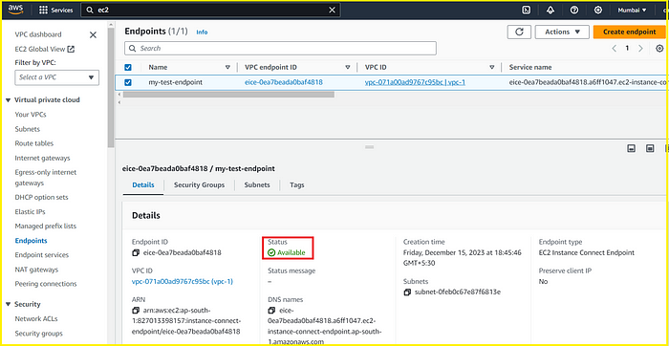

Once the Endpoint becomes available, Proceed to connect the EC2 instance.

**3. Connecting the instance using the VPC endpoint**

Navigate to the AWS EC2 console.

Select the EC2 instance to connect with >> Click Connect

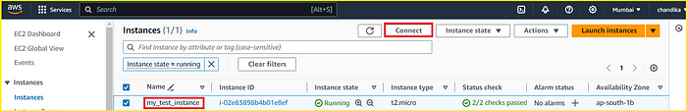

Make sure the instance you are connecting is correct.

**Connection Type:**Connect using EC2 Instance Connect Endpoint

**Username:** **ec2-user** for Amazon Linux or **ubuntu**for Ubuntu OS

**Max Tunnel duration: 3600 (default) —** SSH access is open and active till this time

**EC2 Instance Connect Endpoint** — Select the endpoint that we have created “my-test-endpoint”

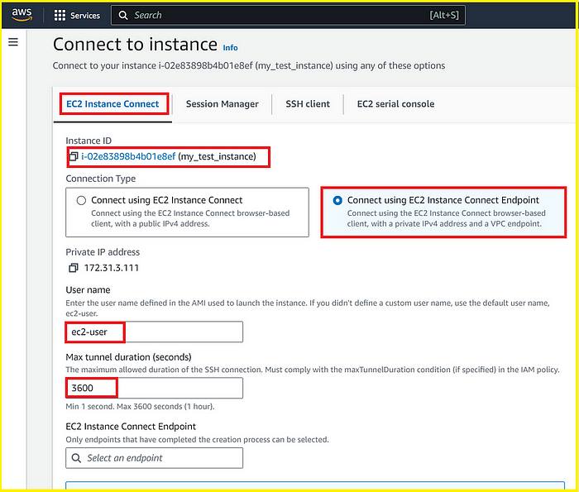

Click on **Connect**

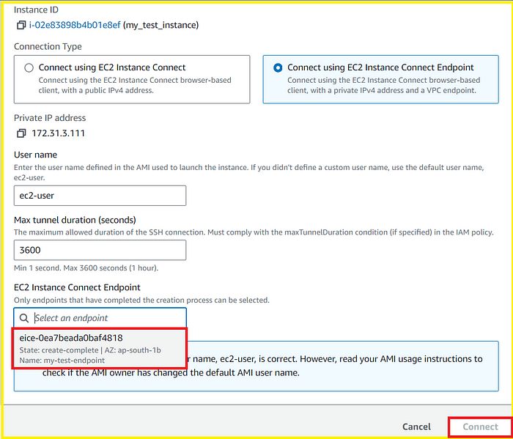

You will see establishing a connection and then connected.